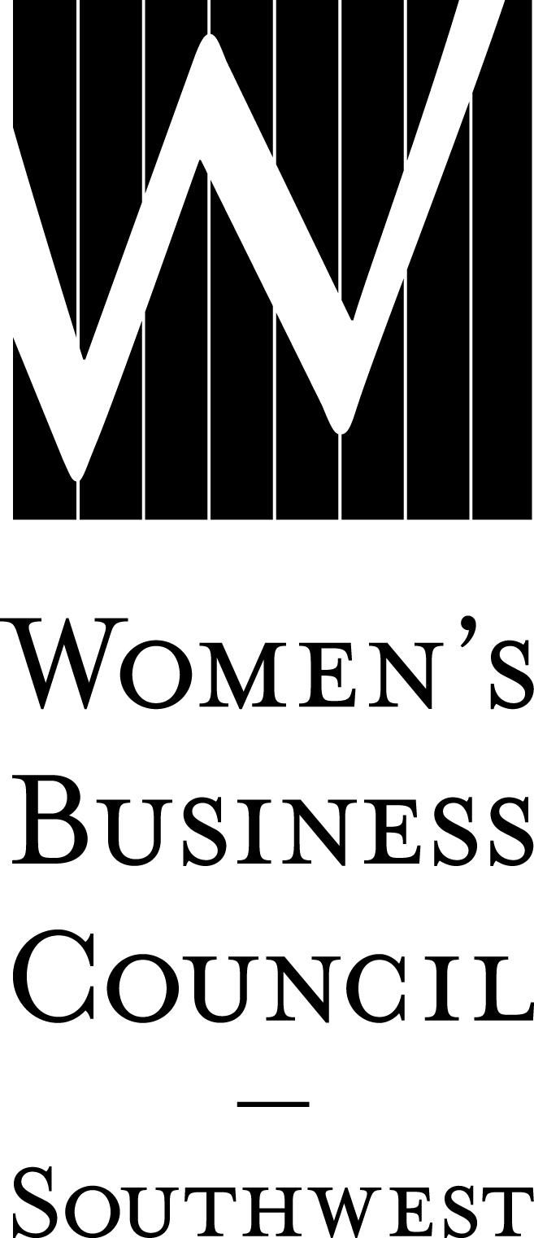2018 Sustaining (Corporate) Bundle/Early Commitment Worksheet Date:
Company:
Contact:
Phone: ( )
Email:

Secure your 2018 sponsorships by submitting this worksheet to the Council by December 15, 2017, and pay by February 1, 2018, to be eligible to receive up to 100% off your membership dues.

I. MAJOR EVENTS Price Cost
Parade of Stars Awards Gala
February 1, 2018
Presenting – 1 @ $15,000 SOLD OUT
Entertainment – 1 @ $10,000 $
Program Book – 1 @ $ 8,000 $
After Party – 1 @ $ 6,000 $
Underwriter $ 5,000 $
Gold $ 2,500 $
Table of 8 $ 1,000 $

Power to Potential
April 17, 2018
Title – 1 @ $ 8,000 $
Power Lunch – 1 @ $ 6,000 $
Procurement Roundtable Sessions – 1 @ $ 6,000 SOLD OUT
Networking Reception – 1 @ $ 5,000 $
Lounge – 1 @ $ 5,000 $
Power Pitch – 1 @ $ 5,000 $
Underwriter $ 3,000 $
Gold $ 2,000 $

Business Works Expo
September 2018
Title – 1 @ $12,000 SOLD OUT
Kick-Off Luncheon – 1 @ $10,000 $
Networking Reception – 2 @ $ 8,500 $ Connections Café – 1 @ $ 8,000 $
Member Directory – 1 @ $ 8,000 $
Matchmaker – 2 @ $ 7,000 $ Platinum $ 5,000 $
Gold $ 3,500 $
Corporate Exhibitor $ 1,500 $
Public Entity Exhibitor $ 400 $

Harvesting Partnerships Educational Symposium
November 2018
Title – 1 @ $ 8,000 $
Lillie Knox Memorial Luncheon – 1 @ $ 6,000 $
Networking Reception – 1 @ $ 5,000 $ Lounge – 1 @ $ 5,000 $
Underwriter $ 3,000 $
Gold $ 2,000 $

II. EDUCATIONAL PROGRAMMING SPONSORSHIP OPPORTUNITIES Price Cost
Dallas/Fort Worth
Table Topics Luncheons (February-November, 2018)
Title – 1 @ $ 6,000 $
Underwriter $ 4,000 $
Gold $ 2,500 $

Executive Insights (July 2018)
Title – 1 @ $ 3,000 $
Underwriter $ 1,000 $

Austin
Woman Entrepreneur’s Exchange (January & July, 2018)
Title – 1 @ $ 2,500 $
Underwriter $ 1,500 $

Winning the Bid (April 2018)
Title – 1 @ $ 1,000 $
Roundtable Host $ 500 $

Austin Insights (September 2018)
Title – 1 @ $ 3,000 $ Underwriter $ 1,500 $
Gold $ 500 $

Arkansas, El Paso, New Mexico and Oklahoma
Regional Events
Title – 1 per state @ Location: $ 2,000 $
Underwriter Location: $ 1,000 $

LILLIE KNOX INVESTING FOR GROWTH GRANT
Underwriter Donor $ 2,000 $
Distinctive Donor $ 1,000 $
Other Amount $

Sponsorship Total = $
Secure your 2018 sponsorships by submitting this worksheet to the Council by December 15, 2017, and pay by February 1, 2018, to be eligible to receive up to 100% off your membership dues.

III. ANNUAL MEMBERSHIP DUES (select one)
More than 1,000 Employees $ 3,000 $
Less than 1,000 Employees $ 1,000 $
Public Entity/Non-Profit $ 1,000 $

IV. BUNDLE DISCOUNT QUALIFICATION
(Do not include membership fee when calculating discount)
If sponsorship total is $7,500 to $12,999; receive a 25% discount off membership dues. - $
If sponsorship total is $13,000 to $19,999; receive a 50% discount off membership dues. - $
If sponsorship total is $20,000 to $24,999, receive a 75% discount off membership dues. - $
If sponsorship total is $25,000 or more, receive a 100% discount off membership dues. - $

V. TOTAL DUE by February 1, 2018
Sponsorship Total + Membership Dues – Bundle Discount = $

