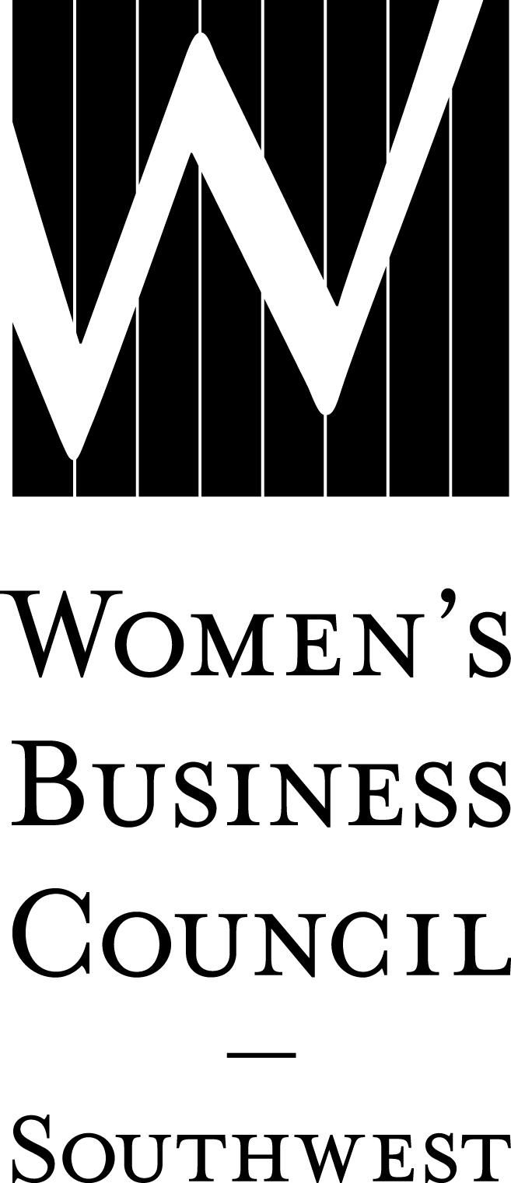2019 WBE Bundle / Early Commitment Worksheet Date:
Company:
Contact:
Phone: ( )
Email:

Secure your 2019 sponsorships by submitting this worksheet to the Council by December 14, 2018,
and remitting payment by February 1, 2019 to receive your 10% discount.

I. MAJOR EVENTS Price Cost
Parade of Stars Awards Gala
January 31, 2019
Presenting – 1 @ $8,000 SOLD OUT
Cocktail Reception – 1 @ $6,000 $
Program Book – 1 @ $6,000 $
After Party – 1 @ $4,000 SOLD OUT
Diamond $2,000 $
Emerald $ 750 $
Ruby $ 500 $
Table of 8 $1,000 $

Connections to Contracts
April 10, 2019
Title – 1 @ $8,000 SOLD OUT
Luncheon – 1 @ $5,000 SOLD OUT
Grab and Go Breakfast – 1 @ $4,500 $
Networking Reception – 2 @ $4,500 $
Program Book – 1 @ $4,000 $
Procurement Roundtable Sessions – 1 of 2 @ $3,500 $
Regional Reception – 1 of 4 @ $1,500 $
Diamond $ 750 $
Emerald $ 400 $

Harvesting Partnerships
September 2019
Title – 1 @ $4,000 SOLD OUT
Luncheon – 1 @ $3,000 $
Themed Roundtable Sessions – 1 of 2 @ $3,000 $
Networking Reception – 1 @ $2,000 SOLD OUT
Diamond $ 750 $
Emerald $ 400 $

II. EDUCATIONAL PROGRAMMING Price Cost
Dallas/Fort Worth
Table Topics Luncheons (February-November 2019)
Title – 1 @ $2,000 SOLD OUT
Diamond $1,000 $

Trade Talk (March, June, October, December 2019)
Diamond $ 500 $

Austin
Woman Entrepreneur’s Exchange (January & October 2019)
Title – 1 @ $1,000 SOLD OUT
Diamond $ 500 $

Austin Insights (July 2019)
Title – 1 @ $1,500 SOLD OUT
Diamond $ 500 $
Emerald $ 300 $

Winning the Bid (September 2019)
Title – 1 @ $ 500 SOLD OUT

Sponsorship Total = $
III. BUNDLE DISCOUNT (10% OF TOTAL)
You are eligible for this discount if your sponsorship(s) total $1,000 or more. - $

IV. LILLIE KNOX INVESTMENT AWARD
Underwriter Donor $ 500 +$
Distinctive Donor $ 250 +$
Other Amount +$

V. FINAL TOTAL must be received by February 1, 2019 = $
Sponsorship Total – Bundle Discount + Lillie Knox Donation

