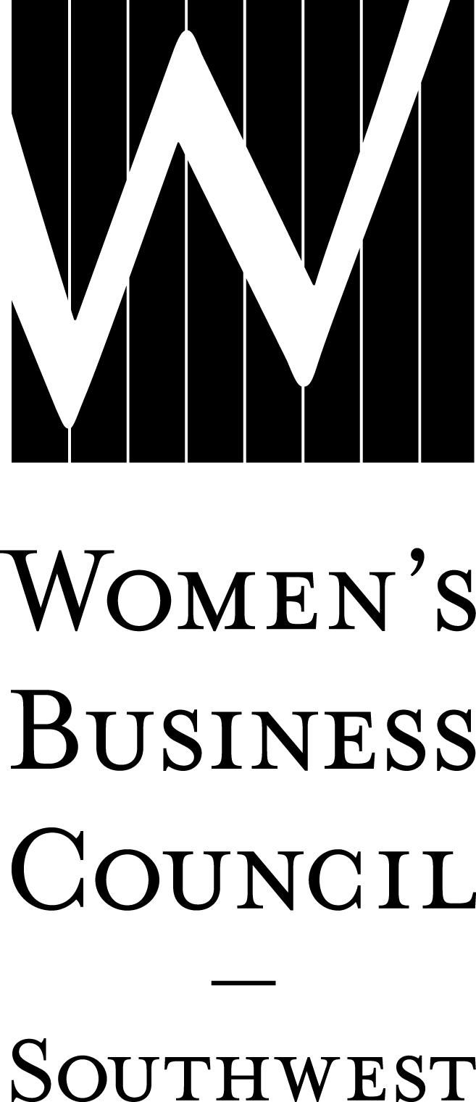2020 WBE Bundle/Early Commitment Worksheet Date:
Company:
Contact:
Phone: ( )
Email:

Please complete and return this form via email to lpittard@wbcsouthwest.org.
Once the form has been sent, please provide a high resolution, vector/jpg version of the company logo via email
to the address listed above. Secure your sponsorships by submitting this worksheet to the Council by
December 13, 2019, and paying by January 31, 2020.

I. MAJOR EVENTS Price Cost
Parade of Stars Awards Gala
February 4, 2020
Presenting – 1 @ $8,000 $
Cocktail Reception – 1 @ $6,000 $
Program Book – 1 @ $6,000 $
Celebratory Gift – 1 @ $4,000 $
After Party – 1 @ $4,000 $
Diamond $2,000 $
Emerald $ 750 $
Ruby $ 500 $
Table of 8 $1,000 $

Connections to Contracts
April 14, 2020
Title – 1 @ $8,000 $
Luncheon – 1 @ $5,000 $
Grab and Go Breakfast – 1 @ $4,500 $
Networking Reception – 2 @ $4,500 $
Program Book – 1 @ $4,000 $
Procurement Roundtable Sessions – 2 @ $3,500 $
Welcome Reception – 4 @ $1,500 $
Refreshments – 1 @ $1,500 $
Diamond $ 750 $
Emerald $ 400 $

Harvesting Partnerships
September 10, 2020
Title – 1 @ $4,000 $
Luncheon – 1 @ $3,000 $
Themed Roundtable Sessions – 2 @ $3,000 $
Networking Reception – 1 @ $2,000 $
Diamond $ 750 $
Emerald $ 400 $

II. EDUCATIONAL PROGRAMMING Price Cost
Dallas/Fort Worth
Table Topics Luncheons (February-November 2020)
Title – 1 @ $2,000 $
Diamond $1,000 $
Subscription Package $ 250 $

Trade Talk (March, June, October, December 2020)
Diamond $ 500 $

Austin
Trade Talk – Austin (January & October 2020)
Diamond $ 500 $

Austin Insights (May 21, 2020)
Title – 1 @ $1,500 $
Diamond $ 500 $
Emerald $ 300 $

Connections to Contracts – Austin (September 24, 2020)
Title – 1 @ $ 750 $
Diamond $ 300 $

Sponsorship Total = $
III. BUNDLE DISCOUNT (10% OF TOTAL)
You are eligible for this discount if your sponsorship(s) total $1,000 or more. - $

IV. LILLIE KNOX INVESTMENT AWARD
Underwriter Donor $ 500 +$
Distinctive Donor $ 250 +$
Other Amount +$

V. FINAL TOTAL must be received by January 31, 2020 = $
Sponsorship Total – Bundle Discount + Lillie Knox Donation

PAYMENT DUE
Please check the appropriate box below for billing. All submitted pledges are considered binding commitments at the level of payment indicated on this form. Benefits begin to accrue immediately upon receipt by WBCS.

- Invoice now
- Invoice in 2019
- Invoice January 2, 2020

Purchase Order # (if applicable): _______ Signature Authorizing Commitment: ____________________________

